 SCHOOL of BUSINESS AND TECHNOLOGY

Department of Engineering and Aviation Sciences

**Smart Delivery**

**Kevin Harper**

**Eli Nbede**

**Montraz Oliver**

Advisor: Dr. Zhang

May 24, 2020

Design of Autonomous Food Delivery Vehicle

By

Kevin Harper, Eli Nbede, and Montraz Oliver

Submitted to the Department of Engineering and Aviation Sciences in partial fulfillment of the requirements for the degree of Bachelor of Science in Engineering at the UNIVERSITY OF MARYLAND EASTERN SHORE

Date

The author hereby grants the University of Maryland Eastern Shore permission to reproduce and distribute publicly, paper and electronic copies of this document in whole or in parts.

Authors Kevin Harper, Eli Nbede, and Montraz Oliver

Signature

Date

Department of Engineering and Aviation Sciences

Certified by

**LIST OF CONTENTS**

**List of Contents……………………………………………………………………………3**

**List of Figures…………………………………………………………………………………………5**

**List of Tables………………………………………………………………………………….6**

**Abstract…………………………………………………………………………………………………………7**

**1 Introduction………………………………………………………………………………………………8**

**1.1 Background/Motivation………………………………………………………………………………….8**

**1.2 Objective……………………………………………………………………………………………….9**

**1.3 Design Requirements……………………………………………………………………10**

**1.4 Design Constraints…………………………………………………………………………..10**

**2. Project Description……………………………………………………………………..11**

**2.1 System Description………………………………………………………………………...11**

**2.2 System Diagram……………………………………………………………………………...12**

**3. Implementation Plan…………………………………………………………………………….12**

**3.1 Tasks………………………………………………………………………………………………….12-14**

**3.2 Team Organization……………………………………………………………………………….14**

**3.3 Timeline/Milestones/Delivery Plan…………………………………………………..14**

**4. Implementation…………………………………………………………………………………...15**

**4.1 Implementation of Task 1…………………………………………………………………….**

**4.2 Implementation of Task 2……………………………………………………………………..**

**4.3 Implementation of Task 3……………………………………………………………………….**

**4.4 Implementation of Task 4………………………………………………………………………….**

**4.5 Implementation of Task 5………………………………………………………………………...**

**4.6 Implementation of Task 6………………………………………………………………………..**

**4.7 Implementation of Task 7………………………………………………………………………...**

**5. Conclusion**

**LIST OF FIGURES**

Figure 1: Starship Delivery Vehicle 11

Figure 2: Electrical System Diagram 13

Figure 3 17

Figure 4: 17

Figure 5 18

Figure 6 18

Figure 7 19

Figure 8 20

Figure 9 21

Figure 10 21

Figure 11 22

Figure 12 23

Figure 13 23

Figure 14 24

Figure 15: Source code and resulting image in OpenCV 25

Figure 16: Edge Detection of UMES Sidewalk 25

Figure 17: Image files captured via iPhone 26

Figure 18: Annotating Sidewalk using LabelMe 27

Figure 19: Annotating Sidewalk using LabelImg 27

Figure 20: Annotating Sidewalk using LabelImg 28

Figure 21: Annotating Crosswalk using LabelImg 28

Figure 22: Annotating Crosswalk using LabelImg ( Google image) 29

Figure 23: XML Files 29

Figure 24: 200 Image Files 30

Figure 25: Annotating Sidewalk using LabelMe 31

Figure 26: JSON to Pascal VOC Dataset Conversion 31

Figure 27: Files of Segmentation Class Visualization 31

Figure 28: Files of Labeled Segmentation Class in PNG Format 32

Figure 29: Single Masked Image of UMES Campus Sidewalk Dataset 33

Figure 30: Input Image with resultant image segmentation prediction 36

Figure 31: Input image with resultant image segmentation prediction 37

**LIST OF TABLES**

Table 1. Project Timeline and Delivery Plan 14

Table 2. Metrics of First Training Run 32

Table 3. Metrics of Second Training Run 33

Table 4. TF-Mini Lidar and Raspberry Pi 3 Schematics 37

**ABSTRACT**

**CHAPTER 1. INTRODUCTION**

Autonomous self-driving vehicles are growing exponentially in popularity within new-age technology. There are only a few level 5 self-driving vehicles that require no human activation to drive. These self-driving cars are being used to transport goods and people around the world. Furthermore, the electric car is preferred more often because it offers economic, global, and environmental benefits. The car that we plan to design will deliver food to people autonomously.

**Background/Motivation**

On the campus of the University of Maryland Eastern Shore, there are many students that worry about their next meal and how they are going to get hold of it in a timely fashion. A college student has numerous responsibilities on their table, which limits their ability to obtain food at an ideal time. Throughout an average college student's day, they might have at least 3 to 6 classes per day, extracurricular activities if they are an athlete or in some type of group, and they have to study to stay on top of their grades. Furthermore, most colleges have freshmen who are not allowed to have cars. And if any student who drives a car must pay a lot of money for parking and fees. This limits the number of college students with cars and increases the number of college students walking around campus. “Among the 214 National Universities that reported these data to U.S. News in an annual survey, the average percentage of students who brought cars to campus in the 2016-2017 academic year was 46.8 percent.”

When college students are in their dorm after a long day of classes and stressful lecturing. They still must do homework and study for their classes. At that point, they are tired of walking and going to get some food that is at least .4 miles away. The combination of the gruesome schedule of college students makes and the tireless walking around campus makes it hard for college students to eat food when it's offered.

What if it was possible to send Campus Universities dining services to students around their dorm room or any location they might possibly be located. This would allow campus living students to have the option to not worry about receiving food without stopping their homework and walking half a mile to their cafeteria or dining services. Autonomous Food Delivery System can be created to deliver food around the campus to any recipient, preferably college students living on campus.

At the University of Maryland Eastern Shore students are offered food at the locations including Students Service Center, Engineering & Aviation Sciences Complex, Hawk’s Nest, Waters Hall. In the Students Service Center, they offer students plateau dining and oasis staff dining. The UMES campus offers food, but they have no form of delivery options for students to receive food on campus. Furthermore, college students often argue and complain about the food they receive from the cafeteria. This leads them to eat the food that the university provides or any other dining services other than the cafeteria options. There should also be an option for students to choose the food they want to receive via delivery options. Instead of dreading the taste of the food they hate, they can designate their specified food to come to their location.

The idea of creating an autonomous food delivery car was sparked by the Starship Delivery Robot. As shown in Figure1, The Starship Robot is a six-wheeled ground robot that can navigate streets and sidewalks, where they offer on-demand package delivery for consumers and businesses. The Starship Robot was created and operated by Starship Technologies in July 2014.

`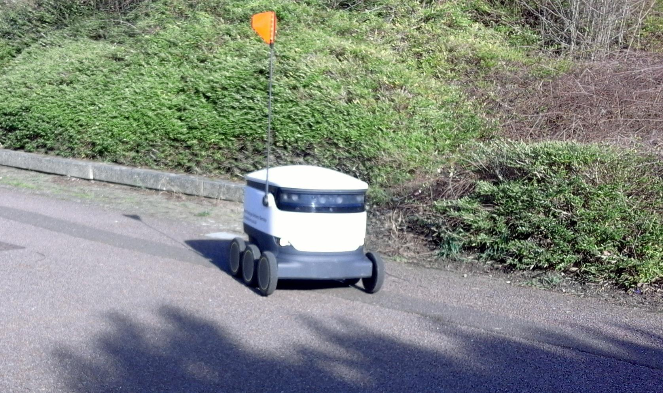Figure 1: Starship Delivery Vehicle

**Objective**

Design an autonomous electric car that can deliver dining services around campus universities

**Design Requirements**

1. Carry up to eight pounds of food
2. Can travel up to a 2-mile radius around campus
3. Will deliver one meal at a time
4. Opening and closing of the food compartment
5. Navigates to different locations on campus
6. Speed of 5-10 mph (ca. 16 km/h)
7. Drive on the sidewalk
8. Detects crosswalk
9. Detects Objects
10. Phone Application
    1. Payment System
    2. Ordering System
    3. Food Tracking
    4. SMS
    5. Client App
    6. The client receives information from customer order

**Design Constraints**

1. Tires might not be able to withstand certain road conditions
2. Not recommended driving in the rain, snow, and thunderstorms
3. The system is incapable of going upstairs or ramp
4. The car is incapable of driving on roadways

**Design Method (Approach)**

The first step of designing our vehicle is to build the structure of the car, that includes the frame or chassis, this is where our electrical components, Arduino microcontroller, and Raspberry Pi we are placed at. The next step will be to connect the motor and ESC to the Arduino and our battery. This is how the vehicle will get the power to operate. The next step will be to configure the GPS and compass with our vehicle. After that, we will configure the LIDAR with a Raspberry Pi so that the Raspberry Pi can give the Arduino commands based on the information it receives from the LIDAR i.e. (object avoidance). Once the LIDAR is completed it can be placed in the front of the vehicle. The GPS and compass will both be placed on the outside of the highest part of the vehicle to receive a signal. The next step will be to interface the application “Mission Planner”. This is the application that we will adopt, the waypoints/directions that our vehicle will travel will be placed on here. The use of telemetry will connect the Mission Planner to our vehicle so that they can seamlessly work together. Once the electrical components are all finished, we can close them in under the frame. Next, the food compartment can be set up. a cup will be designed, and 3D printed. Also, a small frame will also be built to protect the food from rolling around inside the compartment.

**CHAPTER 2. PROJECT DESCRIPTION**

**System Description**

The core system of the electric car is the Raspberry Pi that is interfaced with the camera module, LIDAR sensor, and the Arduino. The driving parameters from the camera and LIDAR such as object detection and lane detection are sent to the Arduino. The Arduino uses the parameters from the Raspberry Pi to control the car. Also, the GPS is interfaced with the Arduino to send and receive location parameters from the website location. The Arduino uses those GPS commands to drive the car to the designated location. Arduino will notify the website when a designated location is achieved through telemetry, so it can then send an SMS to the recipient. Refer to figure 2, as it shows the system diagram of the described system.

**System Diagram (or Flow Chart)**

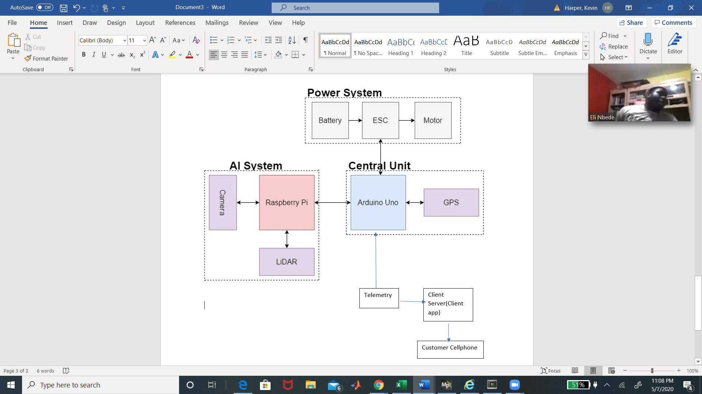 Figure 2: Electrical System Diagram

System Functions

The Arduino acts as the Central Unit in the system that takes the input and output parameters to control the entire system. The Raspberry Pi is a microcomputer that takes sensor inputs from the Raspberry Pi camera and the LIDAR unit for deep learning functions in the self-driving car. The Arduino uses the commands from the Raspberry Pi, and the GPS to determine navigation parameters to control the motor. The Arduino also gains commands from the App to set designated navigation parameters that leads to the enabling of the power system

**CHAPTER 3. IMPLEMENTATION PLAN**

**Tasks**

Task1: Vehicle Structural Design

Subtask 1.1: CAD of Structure

Subtask 1.2: Implement Structure

Subtask 1.3: Design Lock System

Task 2: Design of Electrical Power System

Subtask 2.1: Identify electrical components

Subtask 2.2: Connect Components

Subtask 2.3: ESC configuration with Arduino

Task 3: APP Design

Subtask 3.1: Create Ordering System

Subtask 3.2: Design Payment System

Subtask 3.3: Design Food Tracking System

Subtask 3.4: Design SMS

Task 4: Design of the Artificial Intelligence System

* Subtask 4.1: Design Semantic Segmentation for System
  + 4.1.1: Gather Dataset
  + 4.1.2: Build Semantic Segmentation Model
  + 4.1.3: Train Model
  + 4.1.4: Test and Evaluate Model
* Subtask 4.2: Detection
  + Deploy Pre-Trained Model to Raspberry Pi
  + Design Motion Control Guidelines
  + Design Serial Communication Protocol

Task 5: Design LIDAR System

Subtask 5.1: Design Program for LIDAR sensor

Subtask 5.2: Design connection for LIDAR sensor

Subtask 5.3: Send control and steering commands

Task 6: Navigation

Subtask 6.1: Extract Geographic Coordinate Units

Subtask 6.2: Configure GPS on Arduino

Subtask 6.3: Configure Compass on Arduino

Task 7: System Testing, evaluation, and enhancement

Subtask 7.1: Test Design Requirements

Subtask 7.2: Evaluate and apply changes if necessary

Subtask 7.3: Repeat process

**Team Organization**

3.2.1 **Responsibility of Kevin Harper**

Task 1, Task 2, Task 5, Task 6, Task 7

3.2.2 **Responsibility of Montraz Oliver**

Task 1, Task 4, Task 5, Task 6, Task 7

3.3.3 **Responsibility of Eli Nbede**

Task 1, Task 3, Task 5, Task 6, Task 7

**Timeline/Milestone/Delivery Plan**

**TABLE 1. PROJECT TIMELINE AND DELIVERY PLAN**

|  |  |  |  |  |
| --- | --- | --- | --- | --- |
| Time | Tasks | | | Comments |
| Montraz Oliver | Eli Nbede | Kevin Harper |
| Week 1-3 | Subtask 1.1 | Subtask 1.1 | Subtask 1.1 |  |
| Week 4 -7 | Subtask 4.1 | Task 3 | Subtask 2.1, 6.1 |  |
| Week 8 - 11 | Subtask 4.1& 5.2 | Task 3 | subtask 5.1 |  |
| Week 12-13 | Subtask 1.2, Subtask 4.2, Subtask 5.3 | Subtask 1.3, Task 3 | Subtask 1.2, Subtask 2.2 |  |
| week 14-16 | Subtask 4.3-4.4 | Task 3  Subtask 2.3 | subtask 6.2  subtask 2.3 |  |
| week 17-18 | Subtask 4.3-4.4 | Subtask 6.3 | subtask 6.3 |  |
| week 19-22 | Task 7 | Task 7 | Task 7 |  |

Table 1. Project Timeline and Delivery Plan

**CHAPTER 4. IMPLEMENTATION**

**Implementation of Task 1.**

4.1.1. Implementation of Subtask 1.1

Using SolidWorks figure, 3 & 4, is the design of the cup holder that will be placed inside of the food compartment of the vehicle. We will 3D print this figure and place it cata-corned and either glued down or screwed down in the food compartment. The size of this cup holder will be able to fit a Large Size drink snuggly, smaller sizes will also be able to be placed inside of the cup holder. The design was made like this so that even smaller drinks will not flip over and spill inside the vehicle

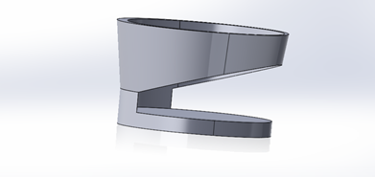 Figure 3

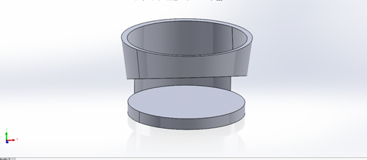

Figure 4:

4.1.2. Implementation of Subtask 1.2

4.1.3. Implementation of Subtask 1.3

……..

**Implementation of Task 2.**

4.2.0 Implementation of Subtask 2.0

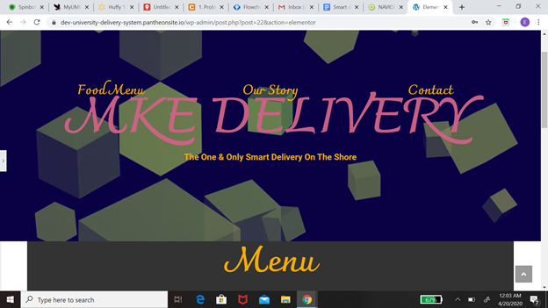

Figure 5

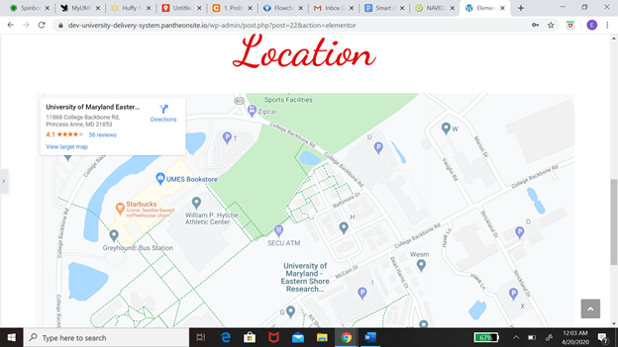

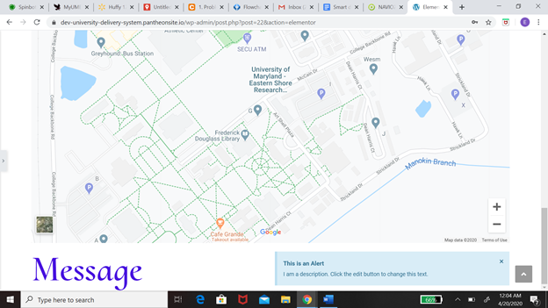

Figure 6

The task at hand is basically designing a system where customers are able to order from and the employees are able to receive this order. This message from the customer will come with two key information on the location of the customer and another being in the order that the customer please. My first solution with the problem at hand was to create a website using Pantheon. One of the main reasons I chose Pantheon was because it is user-friendly. We should allow us to come to the situation with no experience with this application. The approach I took from there was to design the function of the website, which includes the menu, the contact information, location, and basket. The menu was based on the Chick-fil-A menu that is already online so all I needed was a plug-in but one of the problems I ran into while doing that was there was more than one restaurant on campus. So how would I be able to implement multiple menus on this website? After that, I worked on contact information which would include the number. From there I want to create the location and check out basket. I still have some consideration for the program, which includes how to install more than one menu at a time and also have the GPS system tracks the food order. I was never able to add the Message system to the website before moving away from this idea.

<https://dev-university-delivery-system.pantheonsite.io/wp-admin/post.php?post=22&action=elementor>

4.2.1 Implementation of Subtask 2.1

The next path after leaving the website was to create a cell phone app. One of the reasons why I decided to work with a cell phone app was that it is way more versatile. When it comes to different applications like the problem, I have with the messaging system and including the map on the website. The next step to the solution would be to create an application just for the customer. Features on this application would include placing orders, allowing payment sharing, location, messaging system. I will be going to learn more detail about every single feature on this. At first, I need to explain the steps and procedures the App will take to solve these problems. Now I am going to explain my flow chart, which basically shows my thinking process for creating the application. When you first open it is going to take you to the welcome page and on that page, it's going to include sign-in or sign-up. If you already have an account with us, you will be able to sign into the app. If not, you will have the option to sign up. After you successfully sign into the app it will take you to the homepage. The information that will be included on the homepage would be a restaurant, shopping cart and you will be able to search the app from the homepage. Each option will take you to a different page. If you decide to click the restaurant page you would be able to select the restaurant you want to order from and once you do that it would take you to the menu of the restaurant. If you are not satisfied there will be an if statement that will give you the option to take you back to the main restaurant page that has all the different choices. The next part of this app would be the payment, which would include information like credit or debit card information and the name of the person who is buying the food. If you have a promo you can also include that into payment. From there it’s going to take you to a map of the campus, and you will pick your location on the map. This would all be included in your messaging system and your receipt and all that information will be sent to the business you order from and you will receive a text saying the order is complete.

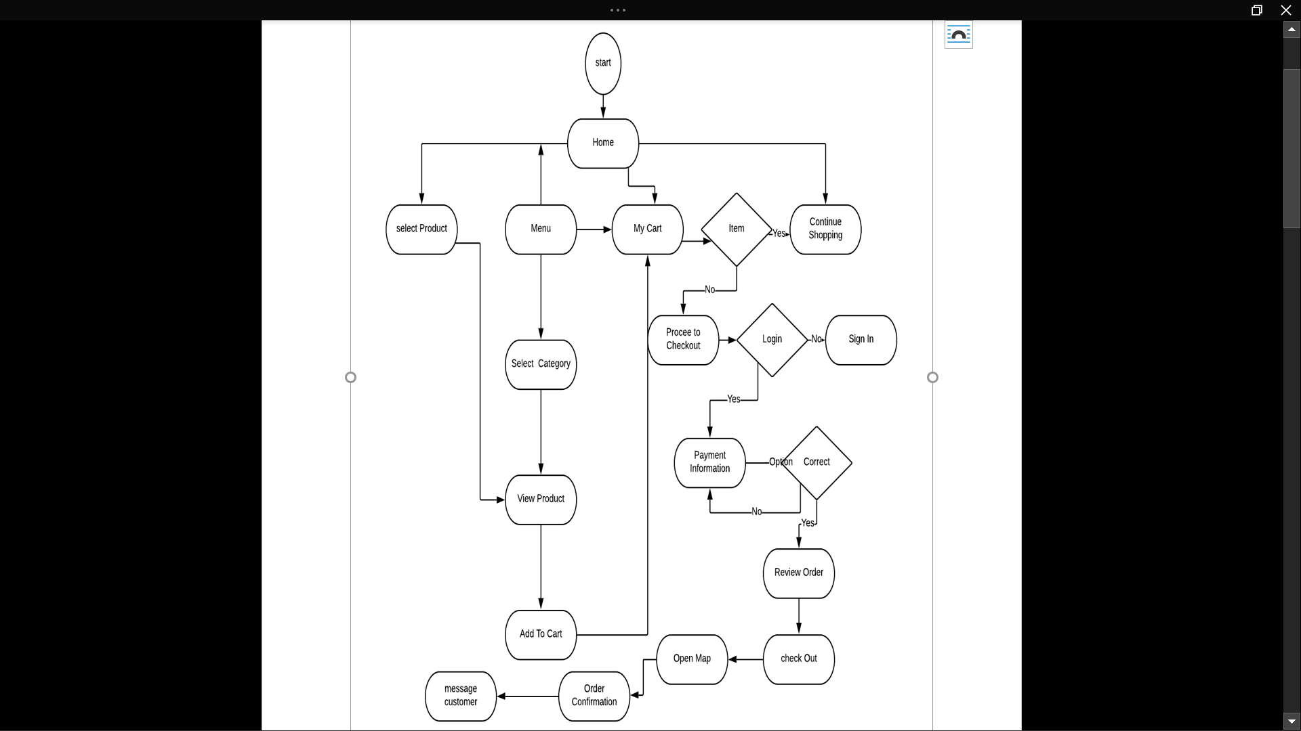

Figure 7

As we dive into more details about this app. The next stage will be discussing how the sign-up page works and going into the whole structure and mostly explaining figure 2 and that should be the flowchart. The first aspect of the sign-up page will also be the most important from the information that will carefully be distributed back-and-forth from the storage to the page itself. The function that is being spoken upon will be the database. The reason why the database was created first was the main way of communication. The decision to use Firebase was a very easy one because Firebase was working very well with the Android studio. To get the Android studio to work with this database all you need to do is connect the IP address and then the plug-in will be able to function well on your Android studio. The next step will be creating the interface which will display multiple different options including boxes and buttons. When you log in to the app The first thing you're coming to counter with would be the sign in page and write below that will be the sign-up page. The way to sign in and sign up will basically be a check system. The way the system works is if you are already a pre-existing customer or app owner. Your information will already be stored in the database so when you put it in your password and your user name and the system will compare the information you put into the information that is stored in a database and check to see if they are the same thing so it would take you to the homepage of the application if not it will return a message saying wrong information. Also have to include people who don’t have an account. In the log game, there will be a sign-up button which would take you to the next page and on them that would include your information like name, address, phone, email, and your password. After all this information is put into the database it will take you back to the login page so you can apply this information and see if everything works - it’s successful. It would take to the homepage and that will lead to the next journey of the application.

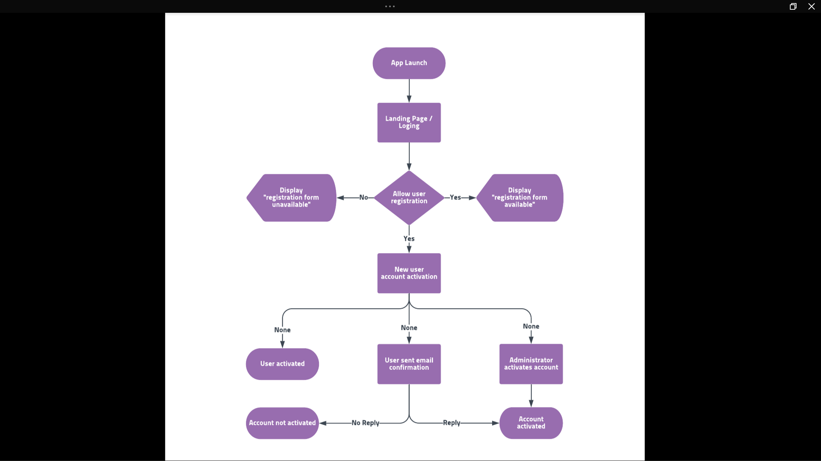

Figure 8

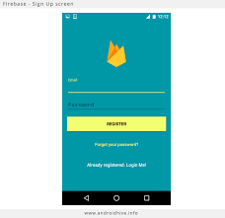

Figure 9

4.2.2 Implementation of Subtask 2.2

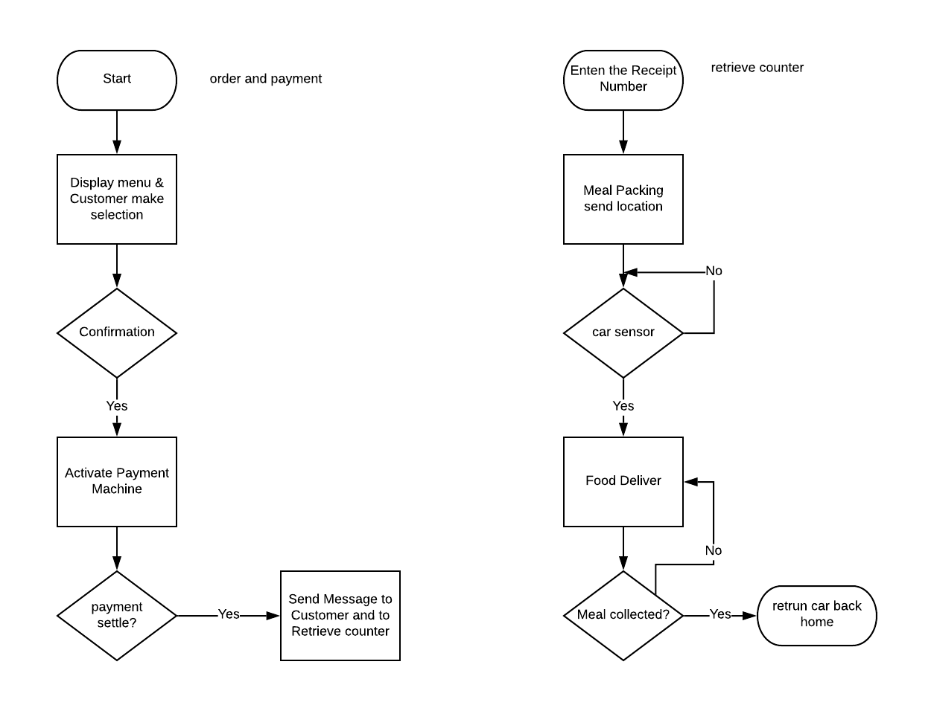

Figure 10

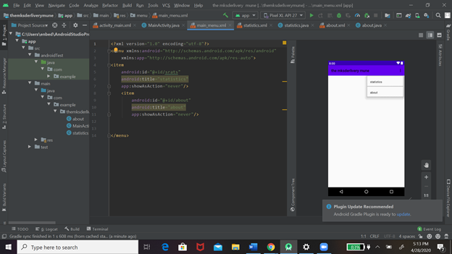

Figure

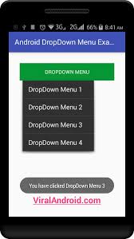

Figure

4.2.3 Implementation of Subtask 2.3

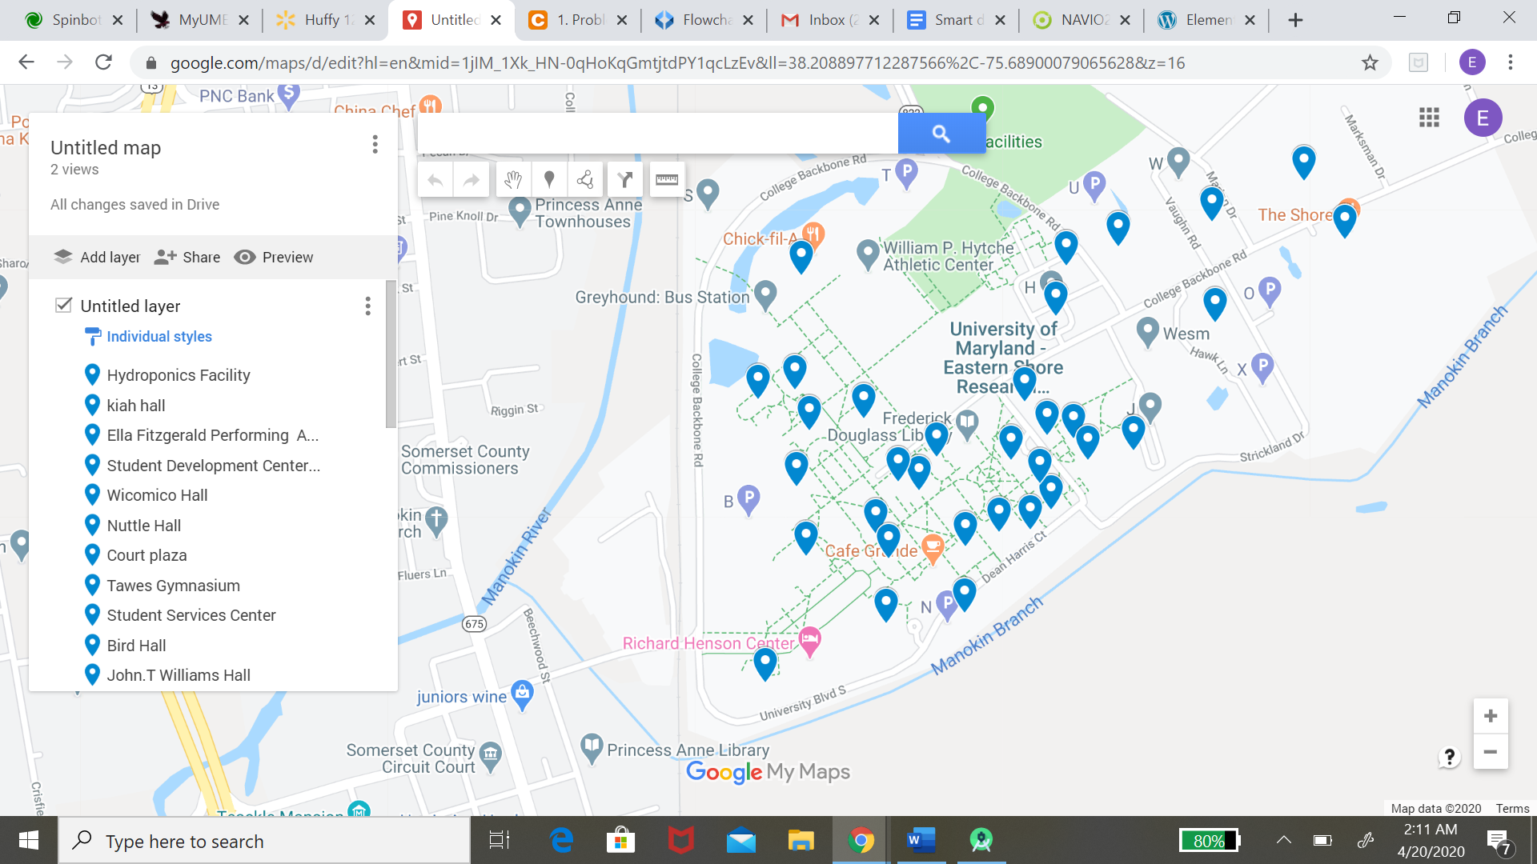

Figure

4.2.4 Implementation of Subtask 2.4

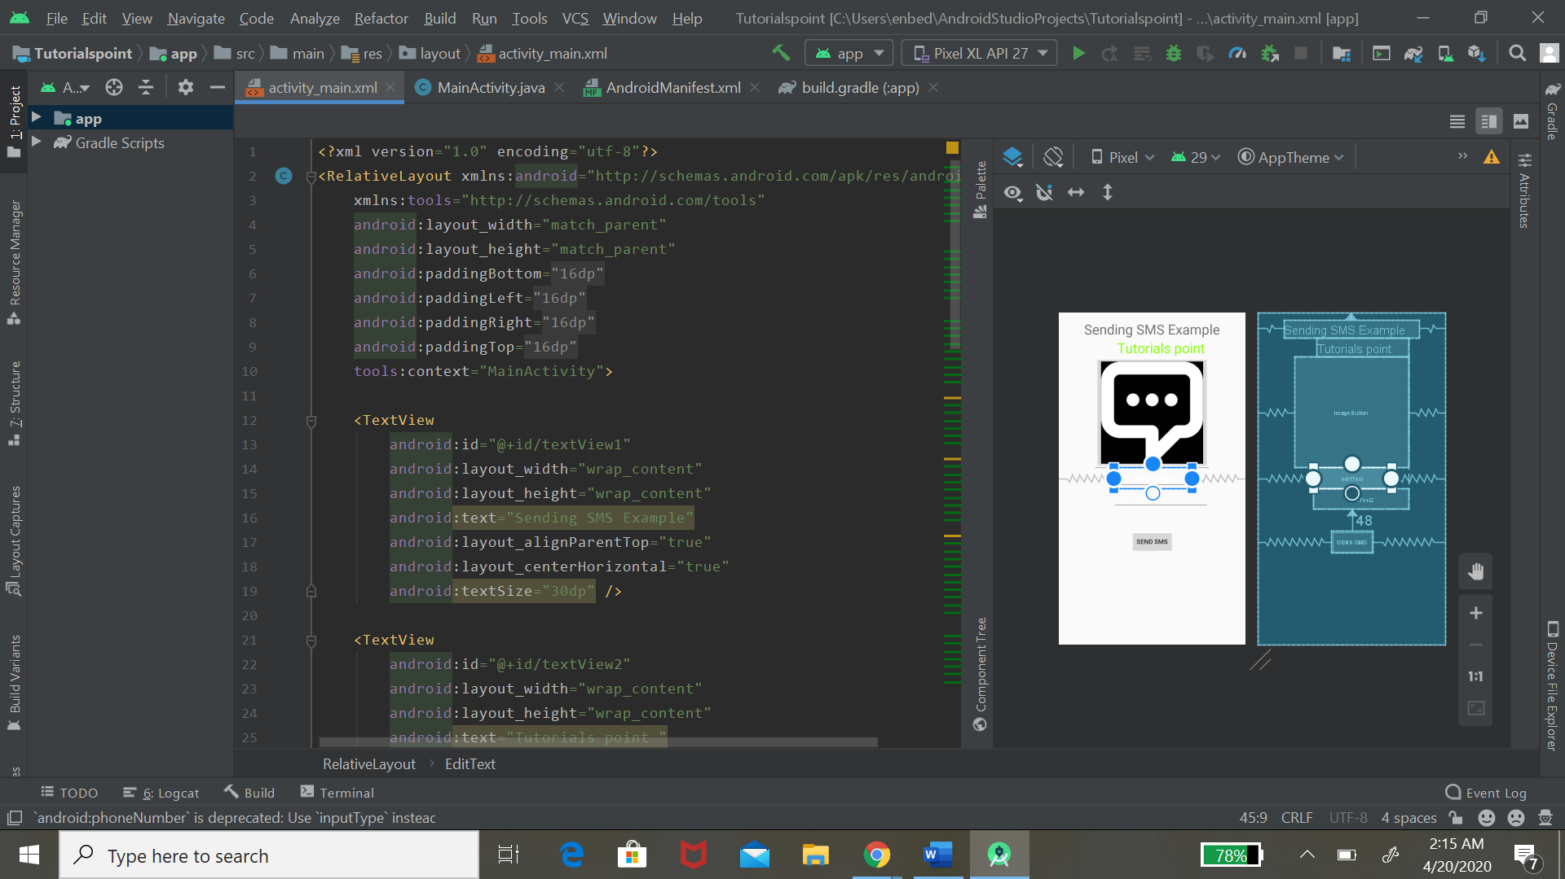

Figure

**Implementation of Task 3.**

4.3.1 Implementation of Subtask 3.1

4.3.2 Implementation of Subtask 3.2

4.3.3 Implementation of Subtask 3.3

**Task 4: Design of an AI System**

**Detected edges on the sidewalk via OpenCV:**

Figure 14 shows the implementation of learning how to read and write files using OpenCV in Python. This was Montraz's first time trying to learn the python language. Being OpenCV is perceived as easier to learn libraries in python than TensorFlow. The first thought as the goal of implementing an artificial intelligence system on the self-driving automobile was to enable the car to detect the sidewalk and drive on it. So, the initial approach was to detect the sidewalk edges in multiple frames with computer vision tactics. The work of canny edge detection was used to detect the edges on the sidewalk shown in figure 15. The approach of using edge detection was to detect the edges of the sidewalk. With the edges of the sidewalk being detected, parameters may always have been set to stay inside those detected lines. Furthermore, the implementation of the edge detection source code is referred to the Appendix section of the report. and the resulting image is shown in figure 16. Because this tactic was more computer vision and most autonomous cars use deep learning. After realizing deep learning would be a more useful method in completing autonomous vehicle driving the task was focused on deep learning and building a TensorFlow neural network to detect the sidewalk.

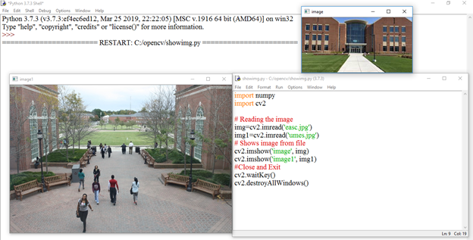

Figure 15: Source code and resulting image in OpenCV

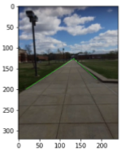 Figure 16: Edge Detection of UMES Sidewalk

**Implementation of Subtask 4.1 - Gathering Data:** In deep learning the self-driving vehicle needs to understand its surrounding. To feed a neural network, a tremendous amount of data has to be fed to the model for convolution and max pooling. A method of determining the difference between objects in a picture is called object detection. The first subtask in the object detection deep learning process is to gain a lot of data to be able to train the neural network. Data includes at least 100-1000 images depending on the detection. The first task of gathering data is capturing images. Figure 17 shows the action of capturing images and importing the files on the PC. Gathering data for object detection also includes annotating objects in an image. There were multiple annotation tools that were used on the images. Where each of them gave different results. Figure 18 shows the annotation tool LabelMe used on an input image. Also, an b-box annotation tool was used as shown in figures 19, 20, 21, and 22. Also those figures show the images in horizontal format, which is not reliable data to annotate.

Not only gathering sidewalks for detection, but also gathering data for crosswalks was a task for the artificial intelligence system. As the approach was for the neural network to detect and predict a crosswalk in frame. Therefore, if a crosswalk were detected then commands would be used to control the motor. Figures 21 and 22 show the annotations and data gathering crosswalks from pictures captured on UMES campus and google images. After annotating images in labeling, the new file generated is an XML file which is shown in figure 23. Using box-annotations tools for labeling cause overlaying different images in one box. Decision was made to focus on the annotation tool using LabelMe. LabelMe is an annotation tool best used for polygon annotation and semantic segmentation of objects rather than using a b-box detection method. Using the polygon annotation gives a good detection of the pixel needed to be detected.

Additionally, in the first implementation of creating a dataset from scratch was to obtain images for the necessary outputs needed for the neural network. After gathering around 300 images and annotating them manually, the images were too big. After researching that when deploying a neural network to the raspberry pi, the images should be a small size compatible enough to run functionally.

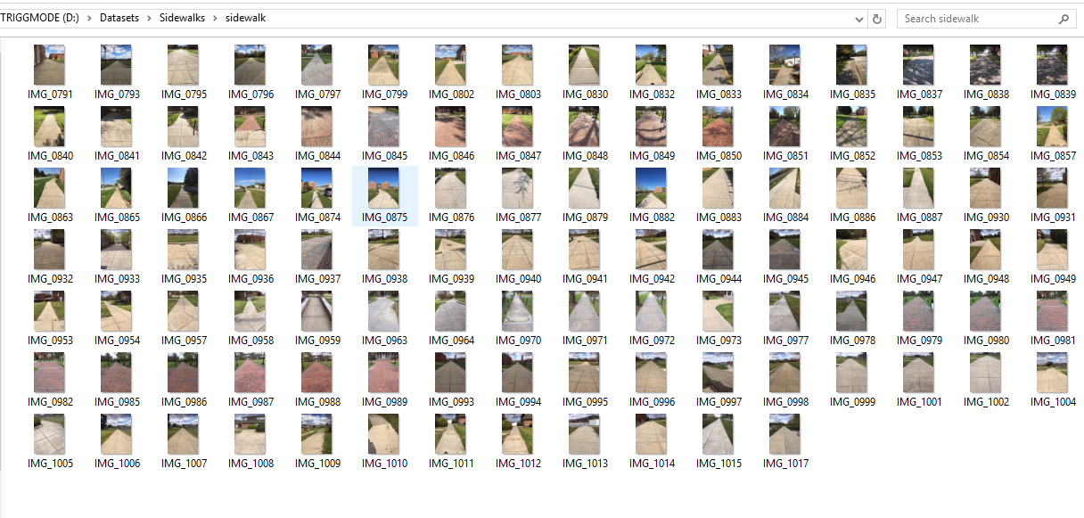

Figure 17: Image files captured via iPhone

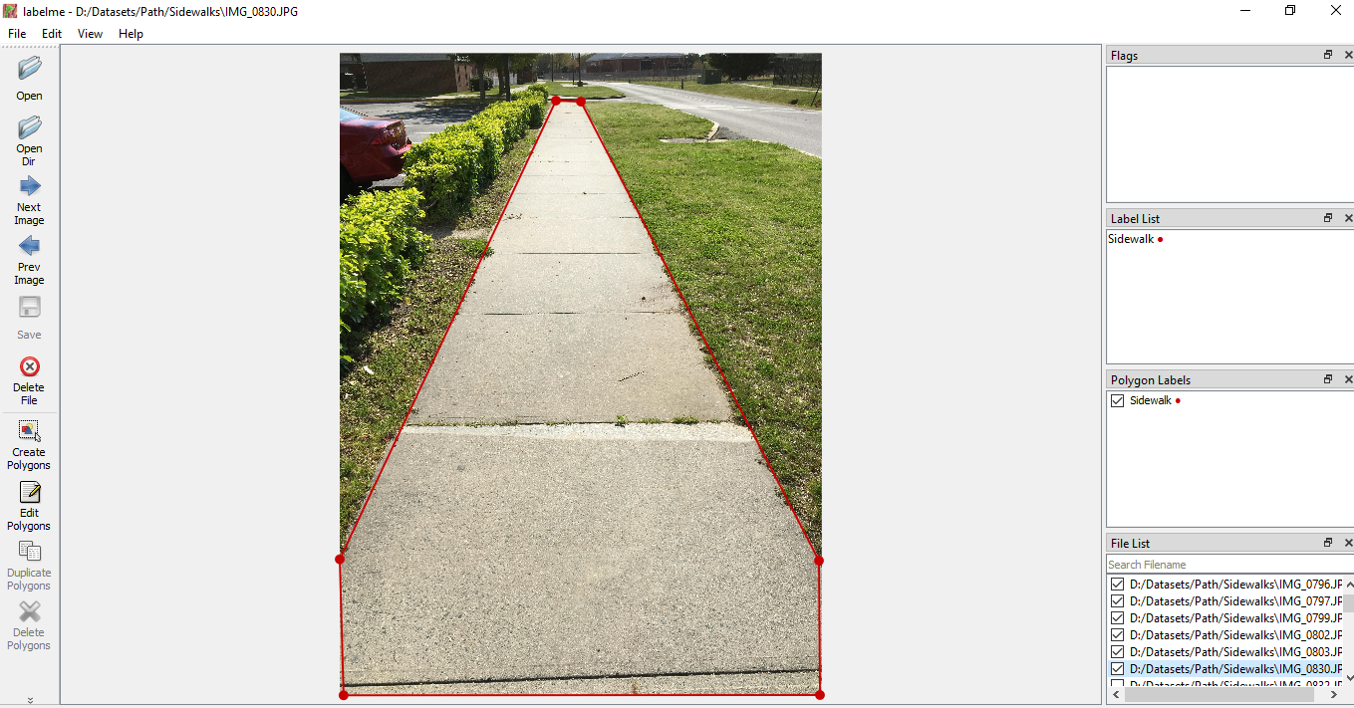

Figure 18: Annotating Sidewalk using LabelMe

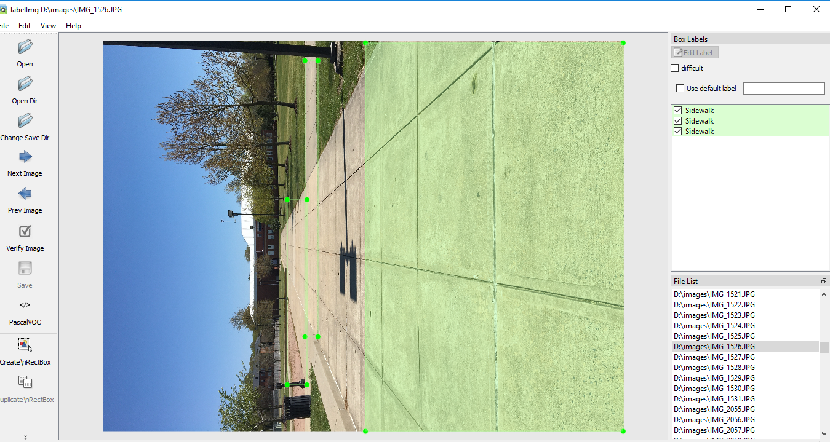

Figure 19: Annotating Sidewalk using LabelImg

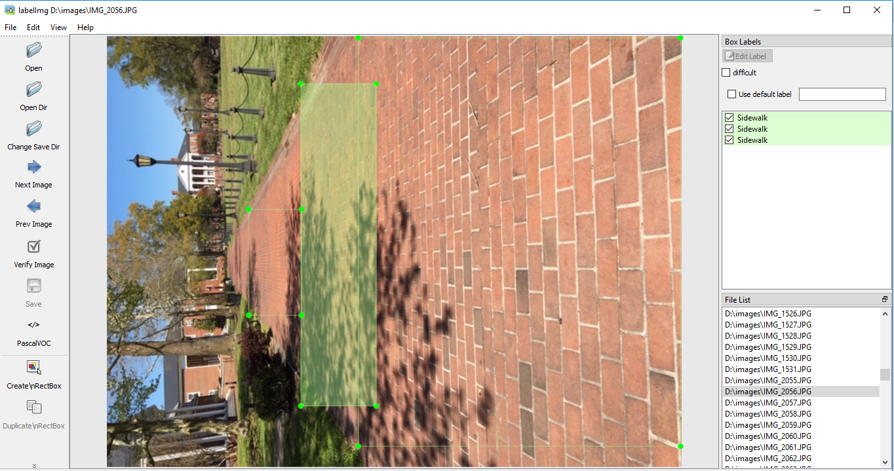

Figure 20: Annotating Sidewalk using LabelImg

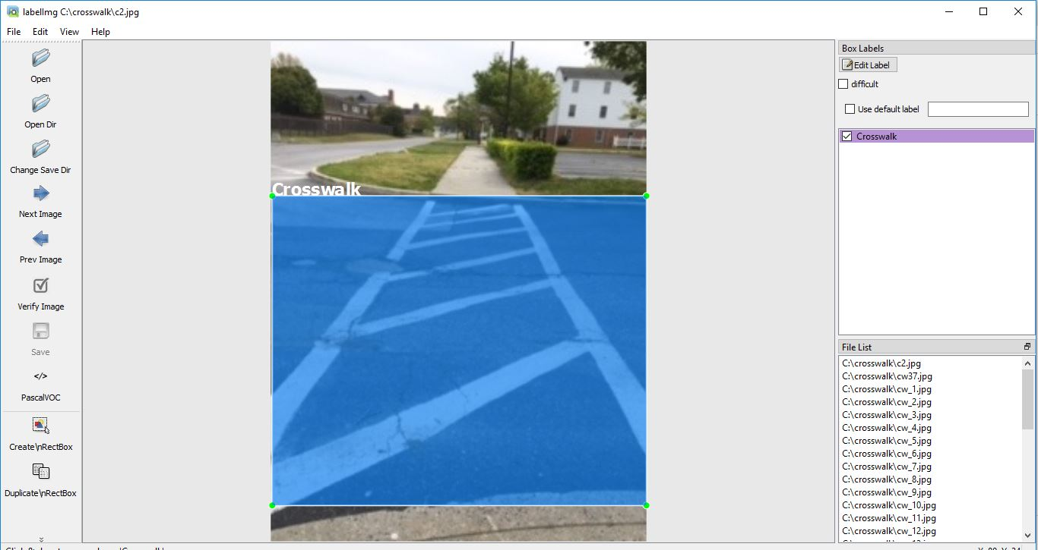

Figure 21: Annotating Crosswalk using LabelImg

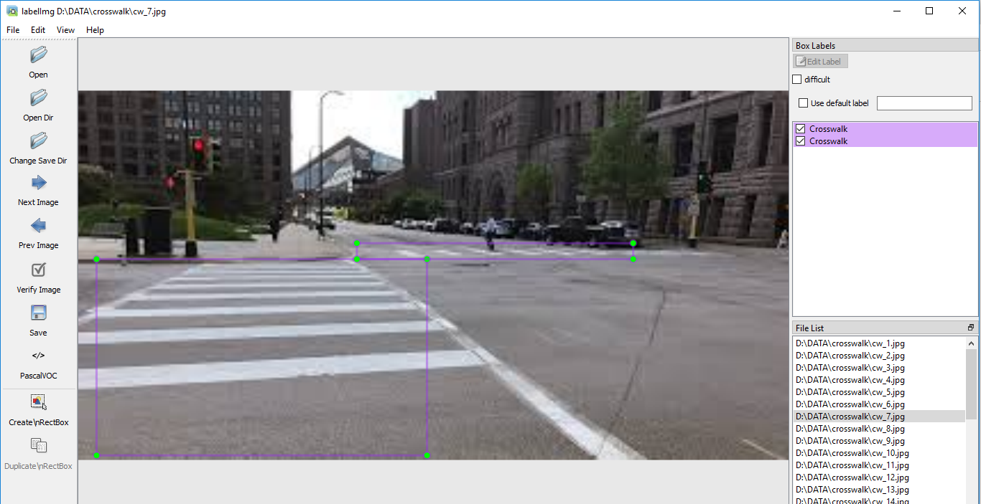

Figure 22: Annotating Crosswalk using LabelImg (Google image)

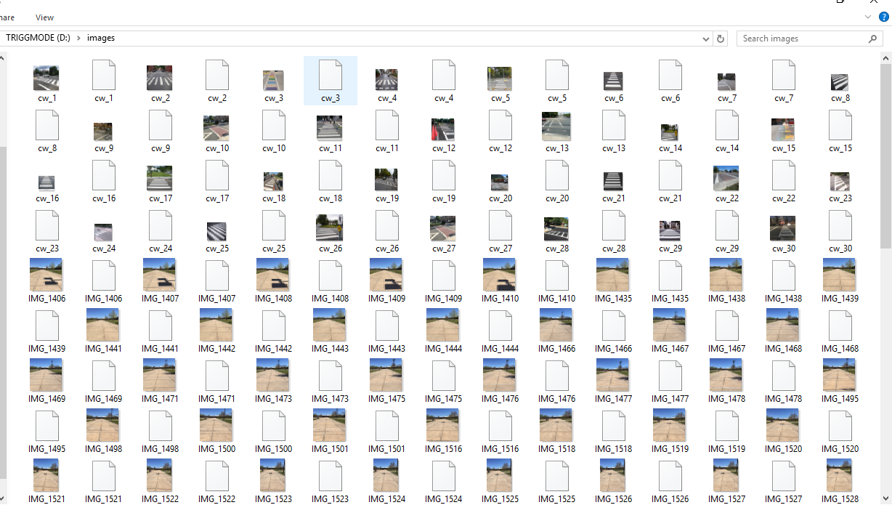

Figure 23: XML Files

**Implementation of Task 4. Design of AI System**

4.4.1: Gather Dataset

In the beginning stages of creating a dataset, there was unfamiliarity of how to perform this task. As shown in the previous figures, photos were captured but the images were too large to feed the neural network. The 300 images taken around the UMES Campus were deleted and taken over again. This time a total of 200 images were captured and downloaded on the pc as small size files. Also, there was confusion on which annotation tool, as LabelImg and LabelMe were used to annotate sidewalks and crosswalks. After further study, the best tool to use to perform our task was LabelMe, because it was a pixel wise labeling tool that is best used for image segmentation. Furthermore, capturing and annotating photos of the crosswalk was for the dataset as we just want to detect sidewalks and differentiate it from the background.

Knowing that raspberry pi prefers to be fed small size images for processing. Figure # shows 200 images captured via iPhone, while each image has a size of 320 by 240. In these photos it includes the main detection, the sidewalk. Along with the background that includes trees, roads, buildings, etc. Each image is manually annotated using LabelMe as shown in figure # which is an image annotator platform used to build databases for computer vision tasks. The image is labeled as either a sidewalk or a background. The trees, building, and everything other than a sidewalk was annotated as the background. Furthermore, the sidewalks in the images were annotated as sidewalks. When annotation is done on image files it creates an JSON file, this must be converted to a file suitable for python. LabelMe provides a source code to convert the JSON files to Pascal VOC dataset formats, refer to the “Appendix B. Source Code” for the source code. Pascal VOC format is an object detection format that has two directories that includes the JPEG Images and the Annotations. Figure 26 shows the command prompt generating the VOC dataset that is represented in figures 27 and 28. The goal was to use that Pascal VOC Dataset and use it as the input layer of Neural Network.

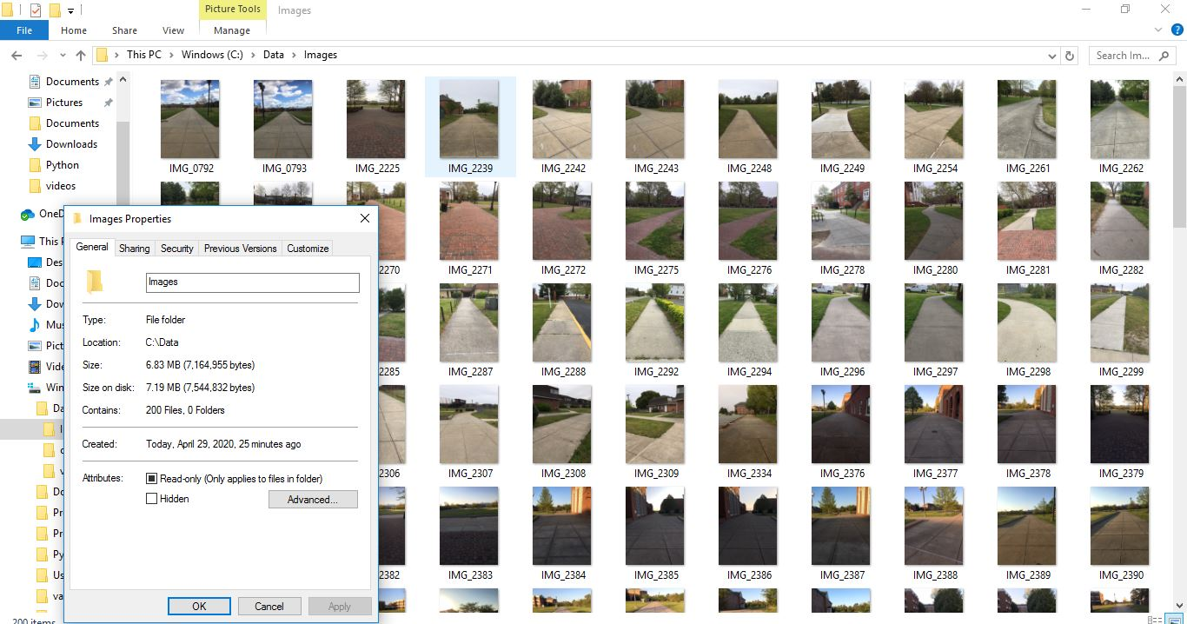

Figure 24: 200 Image Files

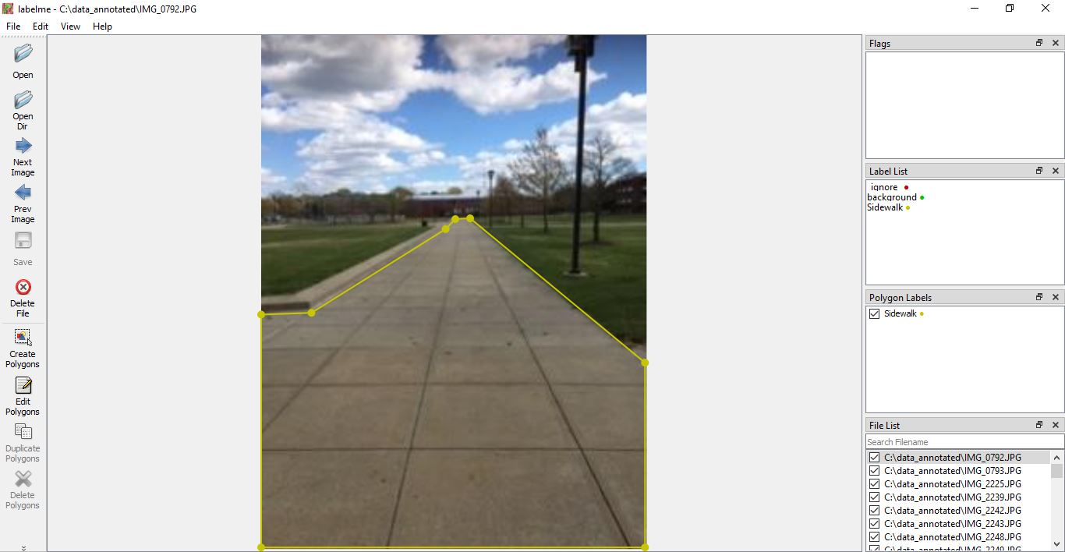

Figure 25: Annotating Sidewalk using LabelMe

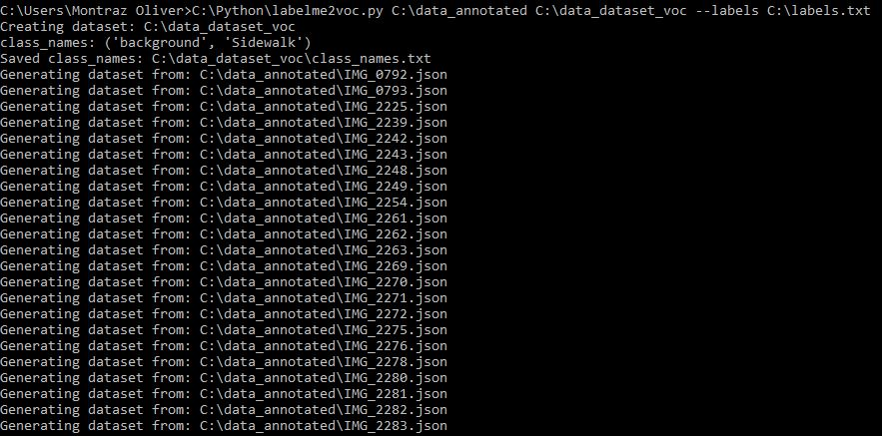

Figure 26: JSON to Pascal VOC Dataset Conversion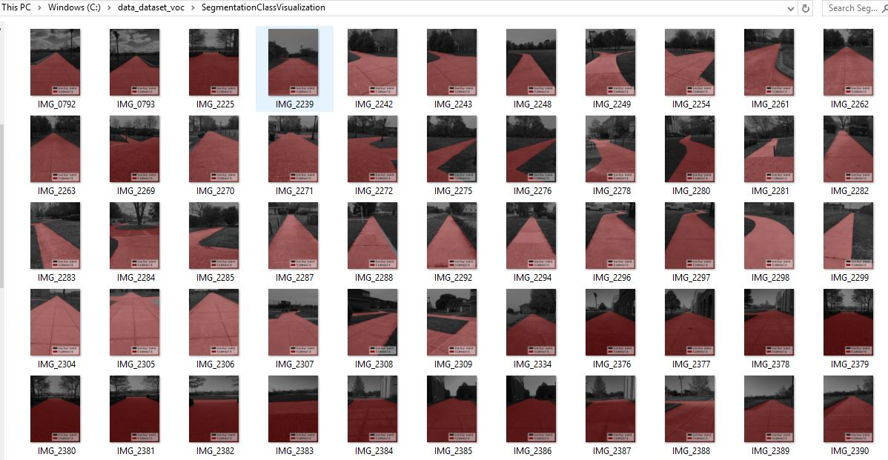

Figure 27: Files of Segmentation Class Visualization

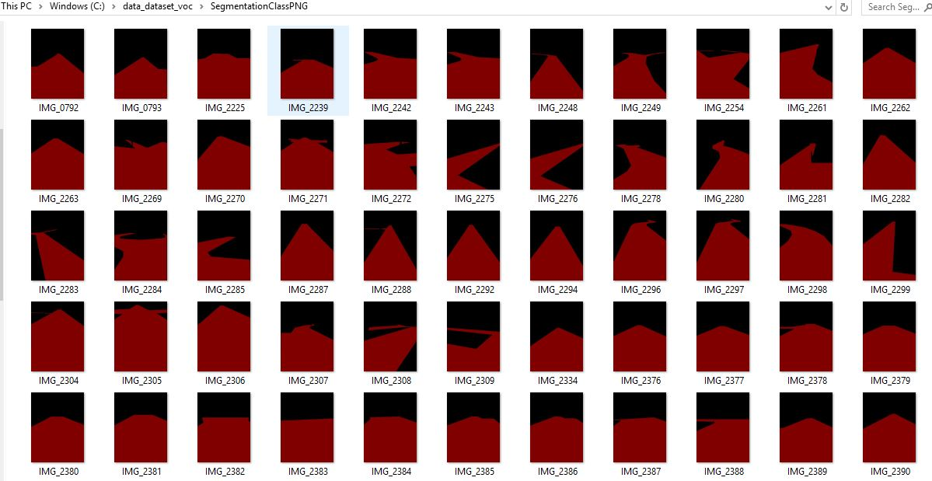

Figure 28: Files of Labeled Segmentation Class in PNG Format

After trying to create a dataset from scratch with more than 200 images captured and annotated, the decision to adapt a living semantic segmentation database came to fruition. The data is the most important aspect of training a neural network. The goal of the artificial intelligence system is to detect the sidewalk as well as its surroundings. The dataset that needs to be created is for semantic segmentation networks. Semantic Segmentation is a fast-growing research field for self-driving cars and robots. Semantic Segmentation links each pixel in an image to a label. With semantic segmentation a range of pixels can receive a label as sidewalk, street, car, etc. This allows the robot platform to detect and extract the usable path from the rest of the scene. In order to achieve this type of goal, there must be plenty of images to be trained. The dataset that was manually created includes 200 input images of the sidewalk scene around the UMES campus. The input images have corresponding labeled data that features only two labels, sidewalk and the background. Also, the dataset includes a text file of the labeled data as sidewalk and background. Therefore, every pixel in the image can be labeled and the differentiation between the sidewalk and the background can be displayed. Figure 29 represents the data mask of a single image after a function is called to create a relationship between the input images and the labeled images. This data is created throughout all the data to be fed into the neural network for training.



Figure 29: Single Masked Image of UMES Campus Sidewalk Dataset

4.1.2: Build Semantic Segmentation Model

Semantic Segmentation is crucial in self driving vehicles and robotics because it is important for the models to understand the context of the environment, they are operating in. Once the dataset is downloaded and converted in a structure that can be used in python. The actions of selecting the type of Neural Network comes into the forefront. There are different Neural Networks for different deep learning tasks. The task of image segmentation in this project will be using the model UNET. A U-NET is a Convolutional Neural Network originally made for biomedical image segmentation but has been proven to perform on any image segmentation tasks. The architecture of a U-NET includes an encoder and a decoder. Where the encoder discovers what is in the image with convolution and max pooling layers. While the decoder determines the “where” information in the data with up-sampling layers. The actual architecture used as a neural network is a Dynamic Unet. The Dynamic Unet allowed us to pass a pre-trained model that sits on top of the encoder. The pre-trained model being used is the Resnet 34. This is helpful as this model has already been trained for image classifications, and the method of transfer learning is used to pass our data for image segmentation through the Dynamic Unet to get the results we need. To build the semantic segmentation model, the Fastai was studied, evaluated, and altered from sources.

4.1.3: Train Model

Training is the stage of machine learning when the model is gradually optimized and or the model is learning the dataset. The objective is to learn enough about the structure of the training dataset to make predictions about unseen images. In a python program for training there are several arguments that must be processed. Arguments include loading the data, data augmentation, the built model, model loss, number of epochs, batch size, list of classes, front-end, and validation. When evaluating the model, the amount loss occurred in model training must come into play. As the model's loss measures how off the model predictions are from the labels. The best method of training a network is on a GPU as the training speed and accuracy is much higher than a model trained on a CPU.

While approaching the method of using a GPU to train the model with the UMES Campus Sidewalk dataset. Technical difficulties came into question when it was time to use a GPU on the windows or Anaconda platforms. Another solution had to come into play, using Google Collaboratory. Google Collaboratory is a free cloud service that allows python programming and it also supports a free GPU. Google Collaboratory is a free Juypter Notebook, that uses a free Tesla K80 GPU it also gives you a total 12 GB of ram. The deep learning application being used on the cloud service is Fastai. Fastai is a Python programming library application that was created to make coding for Artificial intelligence simpler. Also, it is the first deep learning library to provide a single consistent interface to all most used deep learning applications.

There were two instances of training for the Neural Network, as the first neural network being trained will have an input image size of 128 by 128, and the second neural network being trained will have an input image size of 224 by 224. The batch size for the neural network will include four which will go through four iterations of training for every epoch. The number of epochs used for both Neural Networks is 10. In Fastai, to go through the training of the program the learner class and the fit method must be passed. The learner class is essential in training the model as the specification of the data and the model is inputted. The fit method is where the specifications of the number of epochs is made. The learner function uses the dataset created in the program followed by a pre-trained Resnet 34 model. And the fit method calls 10 epochs to be trained for. To see the results of the training a metrics function is called to print a chart that displays the validation loss, the training loss, the accuracy, and the time spent for every epoch. Refer to table 2, as it shows the metrics for the first trained model. In the second training model the input is increased in size to 224. Refer to table 3, as it shows the metrics for the second training model. After the model is learned and trained in the neural network, the model is saved. This allows us to deploy and load the model into a program for ground truth predictions.

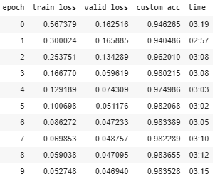

Table 2. Metrics of First Training Run

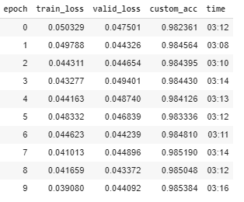

Table 3. Metrics of Second Training Run

4.1.4: Test and Evaluation

When building and training the model in Fastai, the Dynamic Unet has a unique neural network that is built when it is finished training. A typical neural network contains input layers, hidden layers, and an output layer. In the Dynamic Unet model that is used to perform image segmentation has weights, biases, layers, and neurons that are obtained. In the model that was created to perform our neural network contained three sequential layers. A sequential layer allows the model to be layered by layered in a step by step fashion, creating complex layers. In the first sequential layer there is sixteen convolutional layers followed by 16 Batch Normalizations, one Max Pooling layer, and there is eight Rectified linear units (RELU). The second sequential layer includes 20 convolutional layers followed by 20 batch normalization layers and 9 RELU. The third sequential layer has 18 convolutional layers, 5 batch normalization layers, 22 RELU, 2 merge layers, 5-pixel shuffles, 5 pooling average layers, and 5 replication padding layers.

A rectified linear unit is an activation function that is responsible for transforming the summed weighted input from the node into the activation function output. Each neuron in a Neural Network has an activation function. Therefore, there is 39 neurons in the neural network, including the hidden and output layers. The parameters in a neural network includes the number of weights and optionally the biases. The total trainable parameters in this model is 19,957,220.

After training is finished the model is saved to be used as inference learner where output predictions can be performed. The saved model in our case is the second neural network being trained. The time for each epoch took about 3 min for 10 epochs, obtaining about 30 minutes for the total training completion of the Neural Network. The highest accuracy obtained in the training of the neural networks is approximately 98% within 10 epochs. 98% training accuracy is outstanding performance on the dataset, therefore if input images are obtained the correct ground truth image created will be outputted. The model includes assigned weights and biases that allow performance of image segmentation. Using the weighted model, the input images are taken to display the prediction output. Figure 30 shows the code created to display an input image and its corresponding semantic segmentation prediction image. Figure 31 shows another instance of code created to display an input image and its corresponding semantic segmentation prediction image. This method was done on multiple images to see the performance of the predictions. After evaluation of the image segmentations, there is good enough performance for this application to be used on related instances.

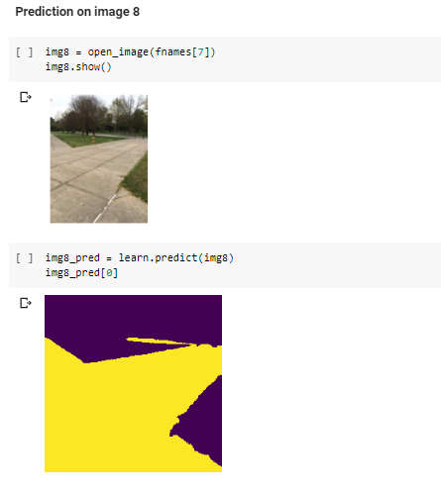

Figure 30: Input Image with resultant image segmentation prediction

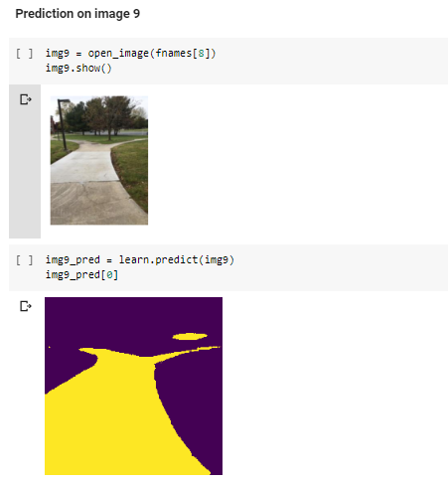

Figure 31: Input image with resultant image segmentation prediction

**Implementation of Task 5.**

4.5.1 Implementation of Subtask 5.1

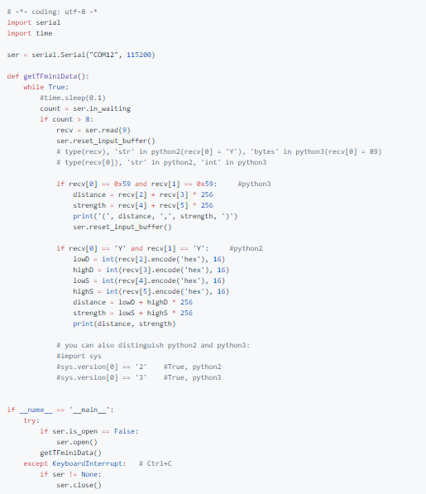 Figure #: This is an adapted code from <https://github.com/TFmini/TFmini-RaspberryPi>. This source code is written in python to program the TF-Mini LIDAR

4.5.2 Implementation of Subtask 5.2

The TF-Mini is a LiDAR Sensor a capable of measuring distance from an object as close as 30 centimeters and as far as 12 meters. The LiDAR must be connected to a board for programming and sensing the data to a computer. The board that will be used is a Raspberry Pi 3 b+, a microcomputer. Table 4 shows the schematics of connecting the LiDAR to the Raspberry Pi

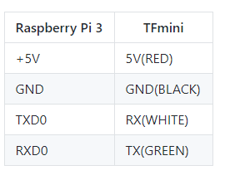 Table 4. TF-Mini Lidar and Raspberry Pi 3 Schematics

4.5.3 Implementation of Subtask 5.3

**Implementation of Task 6.**

For task 6, the goal was to consider how this car is going to be able to navigate to where it needs to go to be able to make its food deliveries.

The first solution that I have investigated was adopting the autopilot’s solution of the application “Mission Planner”. In mission planning, you have access to satellite maps from Google and Bing and then you can establish waypoints by clicking III on the map, as seen in the picture. I establish 5 waypoints on campus that our delivery vehicle can travel. The issue it comes with is trying to run the simulation to test how the vehicle will travel along the waypoints and then return home

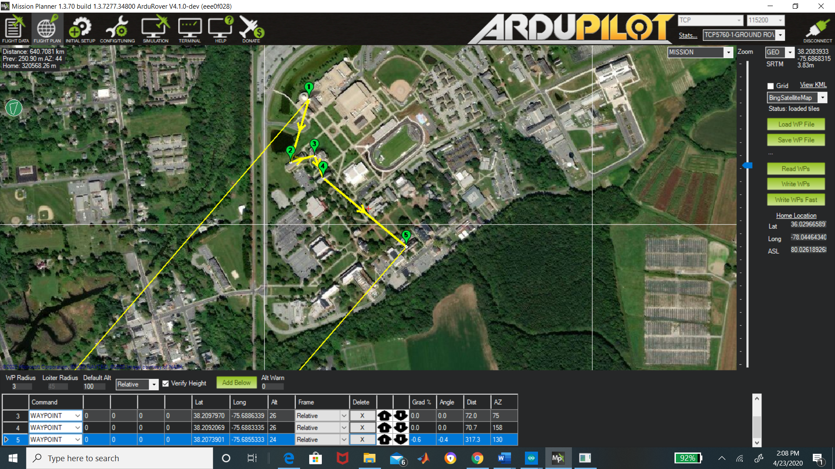

The other solution is accessing using Google Maps platform “Google API”. Google API gives you access to their satellite and the ability to create a set of waypoints/directions. You are allowed up to 25 waypoints for your personal use. In the code below, there is an example you can call upon these directions with your own personal “API” key. When I enter that code below, Google Maps GPS pulls up and then you can set the destination and places in between that destination. For our vehicle, we want it to travel along the confines of campus, so with google API you can differentiate between if you want a “DRIVING” or “WALKING” route. We will use the walking route because that would avoid the car going on the road.

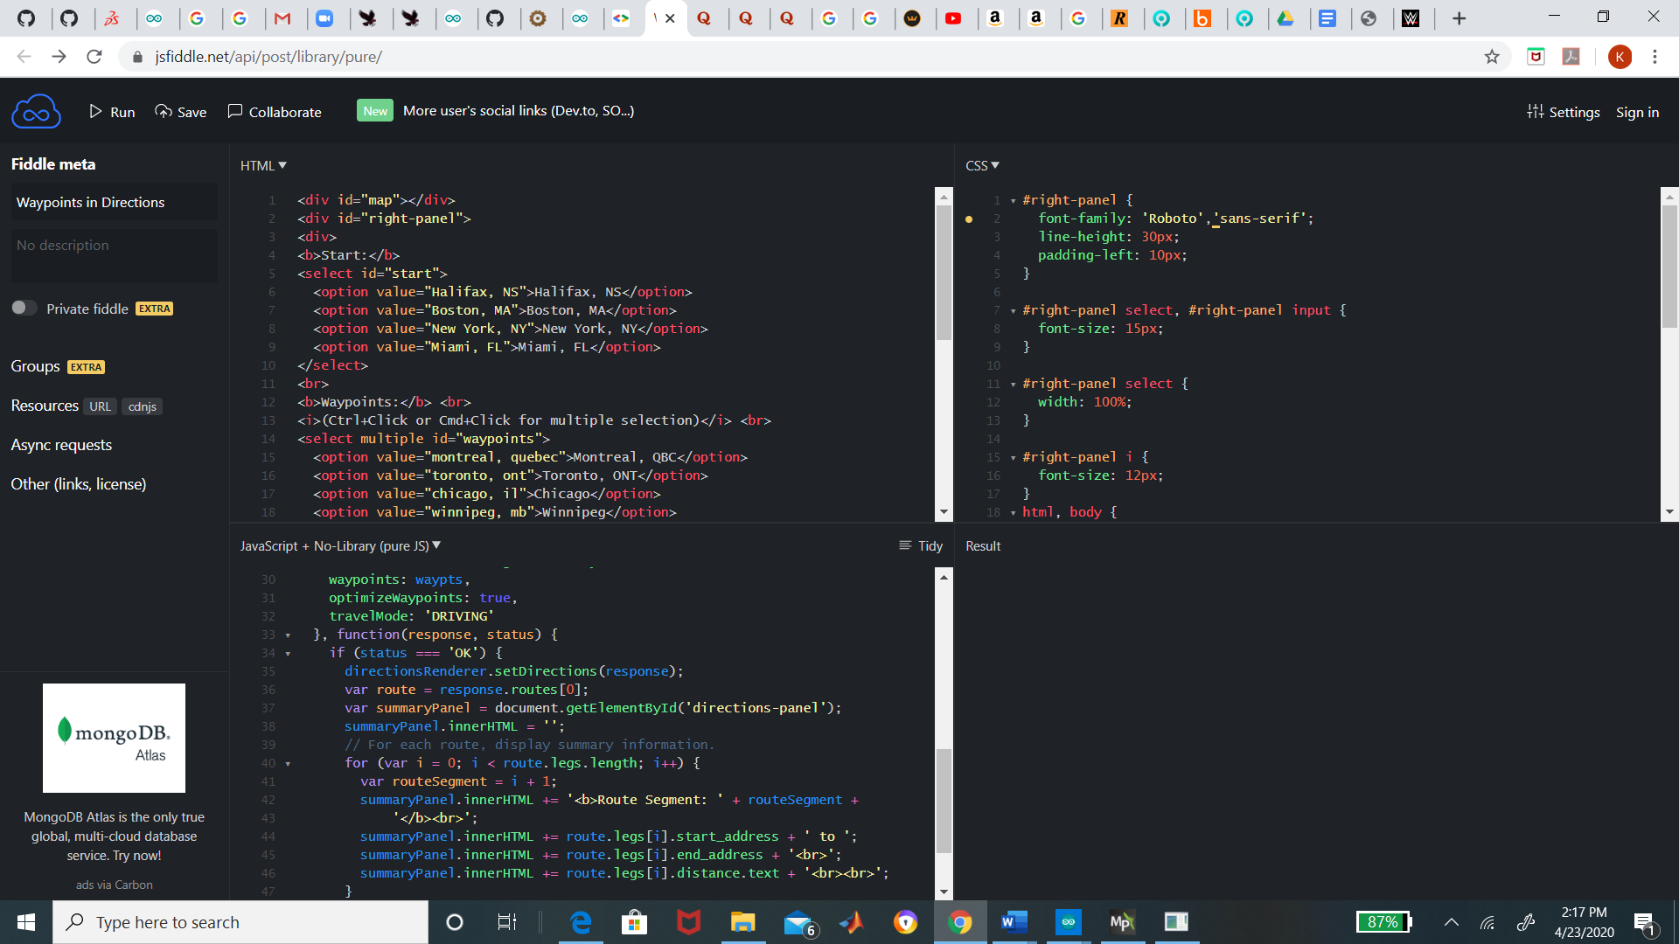

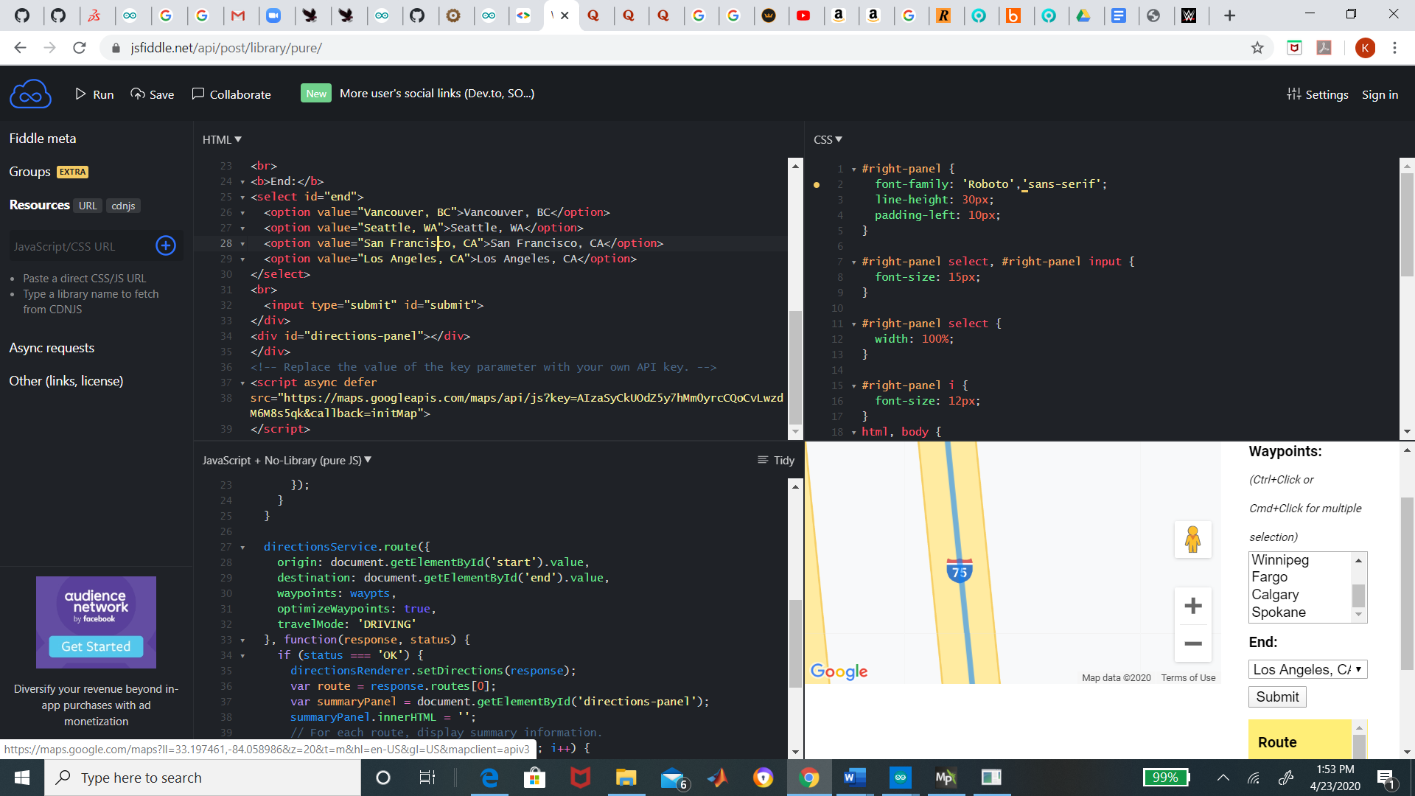

4.6.1 Implementation of Subtask 6.1

4.6.2 Implementation of Subtask 6.2

4.6.3 Implementation of Subtask 6.3

**Implementation of Task 7.**

4.7.1 Implementation of Subtask 7.1

4.7.2 Implementation of Subtask 7.2

4.7.3 Implementation of Subtask 7.3

**CHAPTER 5. PROJECT EVALUATION**

1. Public health
2. Safety
3. Welfare
4. Global Factor
5. Cultural Factor
6. Social Factor
7. Environmental Factor
8. Economic Factor

**CHAPTER 6. CONCLUSION**

**APPENDIX**

1. **Component Specs**
   1. **Specs of TF mini Lidar and Raspberry Pi**

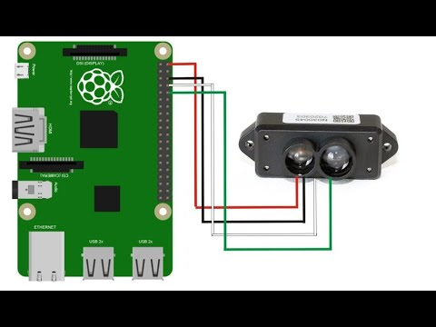

* 1. **Specs of CAD Cup Holder**

1. **Source Code.**
   1. **Source Code of OpenCV Sidewalk Detections**

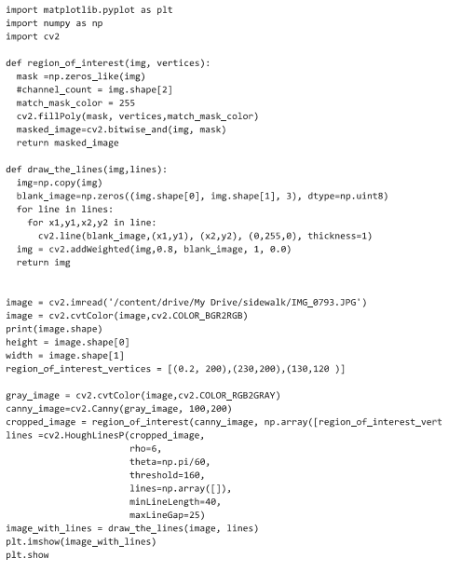

* 1. **Source Code of JSON Conversion to Pascal VOC Dataset**

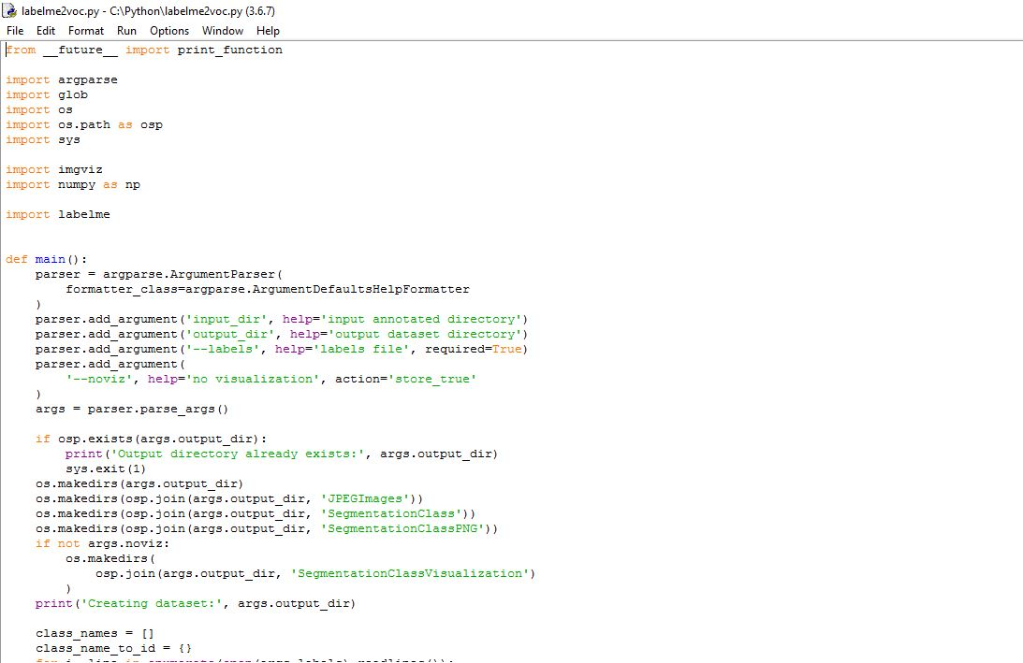

**REFERENCES**